Hello everyone, my name is ____ and I’m part of an organisation called Esprit Science. Our goal is to introduce young students such as yourselves to fields in science, engineering and mathematics that you might not learn at school. For example, today we will be learning some programming, which is a valuable tool to have, since a lot of our daily activities nowadays involve some form of software and computers. Now although we’re trying teach you something that is hopefully new, don’t think of this too much as a lecture, but rather as a workshop with the opportunity to decide whether or not you would like to learn programming. We don’t expect you all to go on and become programmers in the future, but hopefully you’ll all learn something new today and maybe some of you will be interested in learning more.

There are a lot of things that you to know in order to become a proficient coder, but there aren’t a lot of things that you need to know in order to become someone who can code. There are only a few key concepts that you need to understand so that you can do just about anything on Scratch. First off, here’s what scratch looks like.

* open scratch *

Every type of command you can give is colour-coded. For example, if you want the character or obstacles in your game to move, you use the dark blue motion blocks. If you want an object to make an action in response to an event, like pressing start or the space bar, you’ll find the command in events, which is orange. Perhaps the most important type of command are the yellow Control ones. These let you make your other commands be carried out under certain conditions or in different orders - they tie everything together.

Let’s try an example.

For this example we want our character to appear on the screen when we press start and move towards the right of the screen until he hits a red wall. When he reaches it, we want him to stop and say ouch!.

Does anyone have any ideas on how we should do this or where we might find the commands we need?

Okay so that’s a great start; our first task is to get our character to appear on the left of the screen when we press start - that’s an event command and a motion command combined!

We use this block, “when start is clicked” at the beginning, and then the motion command to send the character to a part of the screen. The “x” and “y” mean left/right and up down respectively.

Now we want him to move. We can use the motion command ; move a certain number of steps. Let’s try 10.

Anyone see a problem?

Our character only does this once! We want him to keep doing it till he touches the wall. That’s where those important control commands come in handy. We have one that lets us create a loop of actions, a script, that will be repeated until a certain condition is met.

In the blank spot is where we put the sensory command, until touching the colour red, since our wall is red.

Okay lets try it again. Great it works! He stops. Now we just need him to say ouch! When he bumps into the wall. We’ll use an If-then control command for this!

If he is touching Red, we then want him to say ouch! Any guesses on how to do this?

Yes so we need to use a sensing command again, and then a sound command.

There we go, we’re done!

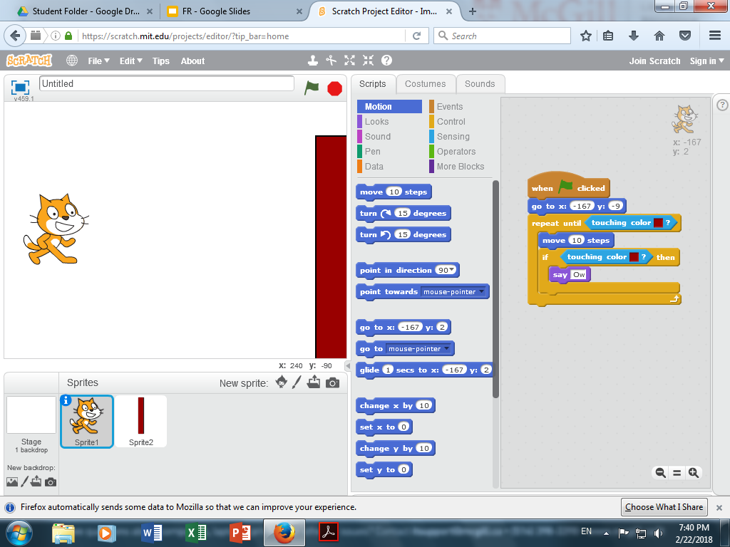

Now for the really fun part! You get to make your own game, Flappy Cat!

Help them open docs etc.